Unit-Under-Test (UUT) 1 – Two 1000uF Capacitors in Series

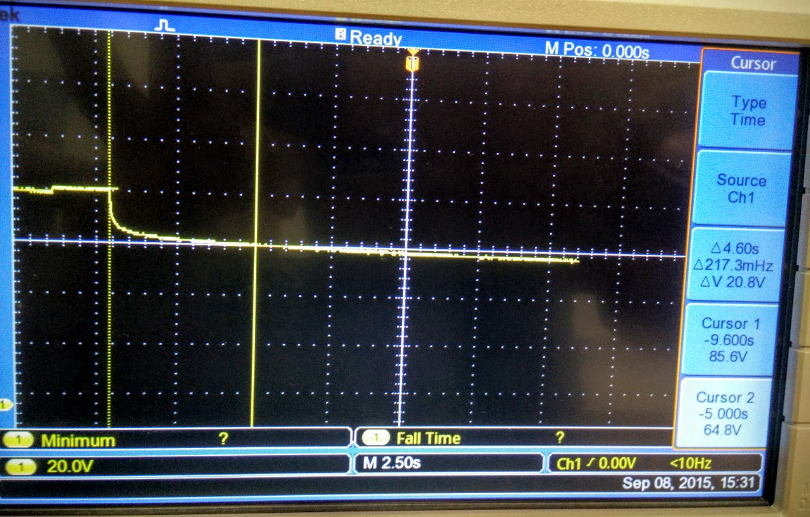 $V_{s}=8.46 V$ (measured from voltage source)

V1 and V2 are two points, the first measured from the point of discharge and the second being the cutoff voltage for the LEDs being used as load.

|  |  |  |  |  |
| --- | --- | --- | --- | --- |
| $$V_{1}/V$$ | $$T_{1}/s$$ | $V_{2}$/V | $$T_{2}/s$$ | $$∆T/s$$ |
| 8.56 | -9.6 | 6.48 | -5.0 | 4.6 |
| 8.56 | 0.7 | 6.40 | 5.0 | 4.3 |
| 8.56 | 0.9 | 6.40 | 5.5 | 4.6 |

Average time to discharge = $≈4.45 seconds$

UUT 2 – Two 1000 uF Capacitors in Parallel

$V_{s}=8.46 V$ (measured from voltage source)

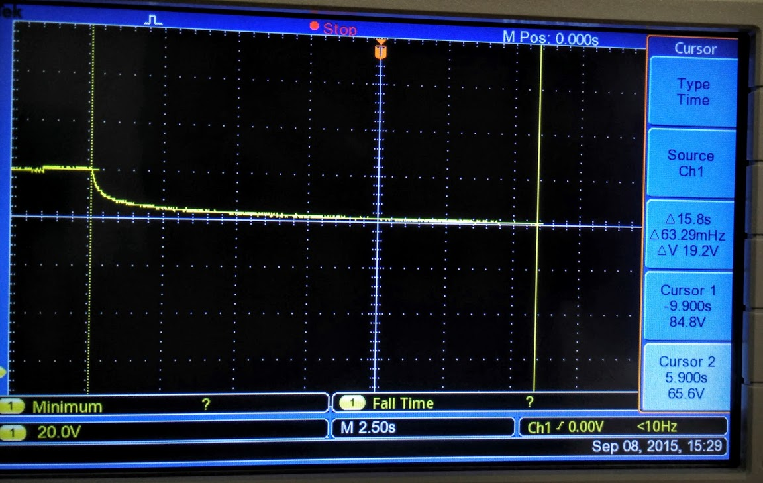

|  |  |  |  |  |
| --- | --- | --- | --- | --- |
| $$V_{1}/V$$ | $$T_{1}/s$$ | $V_{2}$/V | $$T_{2}/s$$ | $$∆T/s$$ |
| 8.48 | -8.9 | 6.56 | 5.0 | 13.9 |
| 8.48 | -8.9 | 6.56 | 5.0 | 13.9 |
| 8.48 | -8.9 | 6.56 | 5.0 | 13.9 |

Average time to discharge = $≈13.9 seconds$

This is keeping with expectations, as the total capacitance in UUT 1 is expected to be 500 uF and UUT2 is expected to have a capacitance of 2000 uF.